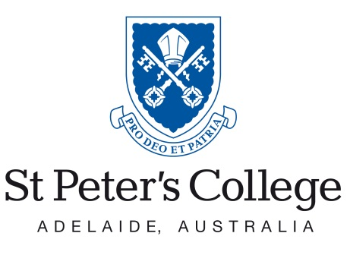 | 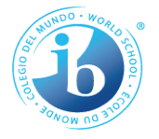

St Peter’s College
Theory of Knowledge
Information Booklet for Students 2020

How do we know what we know?
When a claim is made, how can we verify it?
Why does it matter?
Name:

Table of Contents
Section | Page(s)
Introduction to Handbook | 4
The Role of TOK | 5
The Nature of TOK | 5
The Aims of TOK | 7
Objectives | 7
Frequently Asked Questions | 8
Knowledge | 10
Knowledge in TOK | 11
Shared and Personal Knowledge | 11 - 12
Knowledge Claims and Knowledge Questions | 14 - 15
Ways of Knowing | 16 – 20
Areas of Knowledge | 21 - 24
Assessment Summary and Important Dates | 25
Essay Guide | 26 - 29
Presentation Guide | 30 - 33
Notes | 34

Introduction to Handbook
The purpose of this handbook is to provide students with an overview of the theory of knowledge course. It contains an outline for the structure of the course, including the assessment tasks, as well as an introduction to some of the basic TOK subjects. Some of the material herein is drawn from the IBO TOK Subject Guide, while other information is more specific to TOK at St Peter’s College. More information can be found on the TOK wiki page on Keystone under the code HCR58C.
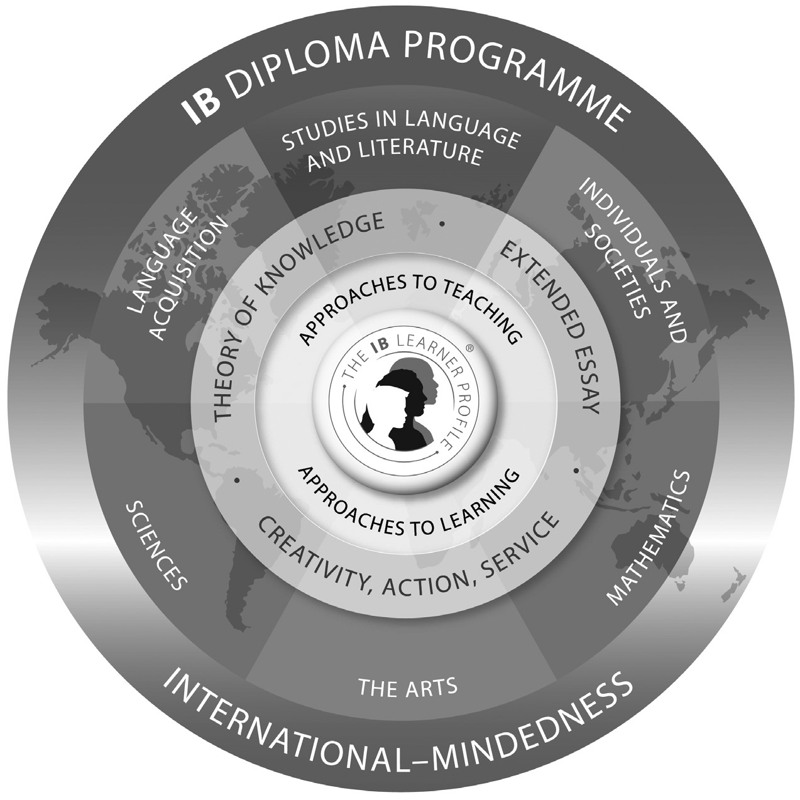

The Role of TOK
TOK, along with the Extended Essay and CAS, is seen as being at the core of the Diploma Programme. This is illustrated in the diagram above. This does not mean that TOK is a more important subject than any of the others, nor does it mean that TOK is worth more in terms of its contribution to your final score out of 45. Instead, the role of TOK is more conceptual and pedagogical. TOK encourages students to think carefully about the nature of knowledge and the ways in which knowledge is acquired and disseminated. The hope then is that students will come to apply this learning to their other areas of study and thus develop a more critical and informed approach to their own learning.
TOK also provides students with a forum in which they can be exposed to differing beliefs and through this exposure come to reflect deeply upon their own beliefs and values. We are all brought up within a particular social and temporal context and this context normally results in us unconsciously acquiring a whole host of beliefs, most of which we never examine or question. Part of the importance of TOK is that it requires us to examine and assess some of these beliefs through confrontation with alternative viewpoints.

The Nature of TOK
TOK plays a special role in the Diploma Programme by providing an opportunity for students to reflect on the nature of knowledge. The task of TOK is to emphasize connections between areas of knowledge and link them to the knower in such a way that the knower can become aware of his or her own perspectives and those of the various groups whose knowledge he or she shares. TOK, therefore, explores both the personal and shared aspects of knowledge and investigates the relationships between them.
The raw material of TOK is knowledge itself. Students think about how knowledge is arrived at in the various disciplines, what the disciplines have in common and the differences between them. The fundamental question of TOK is “how do we know that?” The answer might depend on the discipline and the purpose to which the knowledge is put. TOK explores methods of inquiry and tries to establish what it is about these methods that makes them effective as knowledge tools. In this sense TOK is concerned with knowing about knowing.
The individual knower has to try to make sense of the world and understand his or her relationship to it. He or she has at his or her disposal the resources of the areas of knowledge, for example, the academic disciplines studied in the Diploma Programme. He or she also has access to ways of knowing such as memory, intuition, reason and sense perception that help us navigate our way in a complex world.
It is easy to be bewildered by the sheer diversity of the knowledge on offer. For example:
- In physics, experiment and observation seem to be the basis for knowledge. The physicist might want to construct a hypothesis to explain observations that do not fit current thinking and devises and performs experiments to test this hypothesis. Results are then collected and analysed and, if necessary, the hypothesis modified to accommodate them.
- In history there is no experimentation. Instead, documentary evidence provides the historian with the raw material for interpreting and understanding the recorded past of humanity. By studying these sources carefully, a picture of a past event can be built up along with ideas about what factors might have caused it.
- In a literature class students set about understanding and interpreting a text. No observation of the outside world is necessary, but there is a hope that the text can shed some light upon deep questions about what it is to be human in a variety of world situations or can act as a critique of the way in which we organize our societies.
- Economics, by contrast, considers the question of how human societies allocate scarce resources. This is done by building elaborate mathematical models based upon a mixture of reasoning and empirical observation of relevant economic factors.
- In the islands of Micronesia, a steersman successfully navigates between two islands 1,600 km apart without a map or a compass.

In each case above there is clearly knowledge at work, although the collection as a whole illustrates a wide variety of different types of knowledge. The task of TOK is to examine different areas of knowledge and find out what makes them different and what they have in common.

The Aims of TOK
The overall aim of TOK is to encourage students to formulate answers to the question “how do you know?” in a variety of contexts, and to see the value of that question. This allows students to develop an enduring fascination with the richness of knowledge.
Specifically, the aims of the TOK course are for students to:
- make connections between a critical approach to the construction of knowledge, the academic disciplines and the wider world
- develop an awareness of how individuals and communities construct knowledge and how this is critically examined
- develop an interest in the diversity and richness of cultural perspectives and an awareness of personal and ideological assumptions
- critically reflect on their own beliefs and assumptions, leading to more thoughtful, responsible and purposeful lives
- understand that knowledge brings responsibility which leads to commitment and action.

Objectives
It is expected that by the end of the TOK course, students will be able to:
- identify and analyse the various kinds of justifications used to support knowledge claims
- formulate, evaluate and attempt to answer knowledge questions
- examine how academic disciplines/areas of knowledge generate and shape knowledge
- understand the roles played by ways of knowing in the construction of shared and personal knowledge
- explore links between knowledge claims, knowledge questions, ways of knowing and areas of knowledge
- demonstrate an awareness and understanding of different perspectives and be able to relate these to one’s own perspective
- explore a real-life/contemporary situation from a TOK perspective in the presentation.

Frequently Asked Questions
What is assessed?
There are only two pieces of work that are officially assessed in TOK: the essay and the presentation. The presentation is worth a third of your final mark while the essay is worth two-thirds. Each student will receive two opportunities to do a presentation, but only one attempt at the essay.

How are these assessed?
The presentations are assessed at school by your teachers, but these grades are then externally moderated by the IB. This moderation is done on the basis of the form that you submit when you do your presentation, the TK/PPD. Hence this form is in some ways just as important as the presentation itself. The essay is marked externally by IB examiners.
Both the essay and the presentation are assessed using the assessment instruments provided by the IB. Students should familiarize themselves with these before attempting any form of assessment.

Can I choose my own presentation and essay topics?
When deciding on a topic for the presentation, students will need to come up with their own real-life situation and then develop a knowledge question to be analysed from this situation. While this should be done in consultation with your teacher, you have a lot of leeway in terms of what you are able to do.
For the essay, however, the IB provides a list of six topics for students to choose from. Students must choose from this list. Essays that do not address one of the prescribed topics will receive a 0.

How many points does TOK count for?
The EE and TOK together contribute 3 points towards your Diploma. These bonus points can play an important role in meeting university points offer.
Failing to adequately complete TOK is a failing condition for the Diploma. If you get an E grade for either TOK or the EE, you will not be eligible for the Diploma.
The bonus points matrix look as follows:

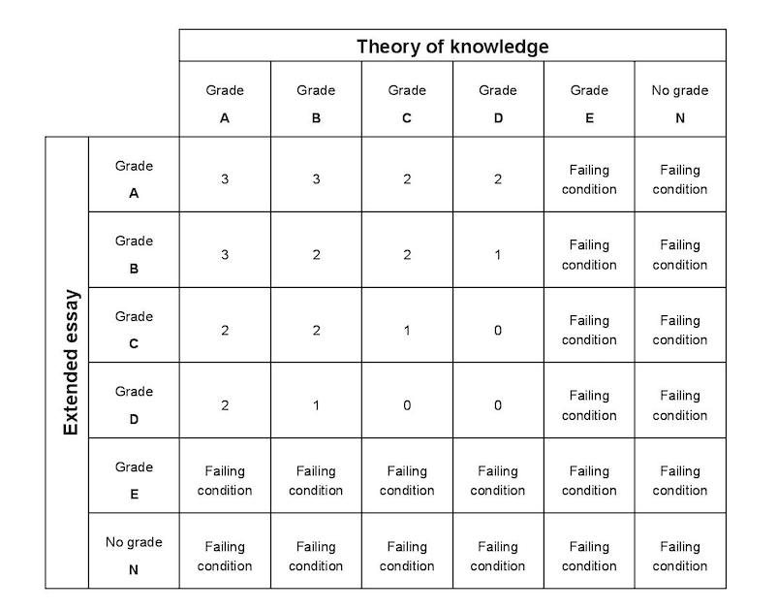
How are the marks related to the grades above?
The tables below outline the grade boundaries for three sessions. Students should keep in mind, however, that these grade boundaries are subject to change and hence that the table below may not reflect the grade boundaries for your cohort.

May 2015
Grade | E | D | C | B | A
Mark Range | 0-4 | 5-10 | 11-16 | 17-22 | 23-30

November 2015
Grade | E | D | C | B | A
Mark Range | 0-4 | 5-10 | 11-16 | 17-22 | 23-30

May 2016
Grade | E | D | C | B | A
Mark Range | 0-3 | 4-9 | 10-15 | 16-21 | 22-30

November 2016
Grade | E | D | C | B | A
Mark Range | 0-4 | 5-10 | 11-16 | 17-22 | 23-30

May 2017
Grade | E | D | C | B | A
Mark Range | 0-3 | 4-9 | 10-15 | 16-21 | 22-30

November 2017
Grade | E | D | C | B | A
Mark Range | 0-4 | 5-10 | 11-16 | 17-22 | 23-30

May 2018
Grade | E | D | C | B | A
Mark Range | 0-3 | 4-9 | 10-15 | 16-21 | 22-30

November 2018
Grade | E | D | C | B | A
Mark Range | 0-3 | 4-10 | 11-16 | 17-21 | 22-30

Knowledge
The TOK course is structured around the concept of knowledge. Our everyday use of the term 'knowledge' is, however, relatively vague. The start of the philosophical discussion of knowledge begins with Plato's dialogue the Theaetetus. Here Plato is presented with a number of distinct conceptions of knowledge by Theaetetus. Plato considers and rejects three main conceptions of knowledge:
1. Knowledge is perception (151d-187)
2. Knowledge is true belief (187b-201c)
3. True belief with an account (logos; 201c-210a)
Primarily as a result of Plato's discussion, most philosophers adopted what became known as the tripartite theory of knowledge. In order for me to know X on this theory, I must:
- Believe X - If I don't believe X then I cannot know X
- My belief in X must be justified - If I do not have good reasons for believing X, then I cannot know X. Beliefs cannot just be accidental.
- X must be true - If X is false, then I cannot know it, although I can of course believe it to be true. That X is true transforms mere justified belief into knowledge.
Thus, the tripartite theory holds that knowledge is justified, true belief.
In 1963, however, Edmund Gettier published a paper entitled 'Is Justified True Belief Knowledge?' In this paper, Gettier presented a series of what became known as 'Gettier cases' which purport to show that having a justified true belief is not always sufficient for knowledge. Much of epistemology since this paper was published aims to determine what needs to be added to justified true belief in order to turn it into knowledge.

Knowledge in TOK
TOK, however, is not intended to be a course in philosophy. While there might be a certain degree of overlap in the terms that are used, the questions that are asked, or the tools that are applied to answer these questions, the approach is really quite different. It is not a course of abstract analysis of concepts. TOK is designed to apply a set of conceptual tools to concrete situations encountered in the student’s Diploma Programme subjects and in the wider world outside school.
The IB then doesn’t really favour the tripartite theory of knowledge, perhaps because it seen as being too restrictive with respect to students’ analyses. Instead, the IB presents students with the metaphor of knowledge as a map. A map is a representation, or picture, of the world. It is necessarily simplified—indeed its power derives from this fact. Items not relevant to the particular purpose of the map are omitted. For example, one would not expect to see every tree and bush faithfully represented on a street map designed to aid navigation around a city—just the basic street plan will do. A city street map, however, is quite a different thing to a building plan of a house or the picture of a continent in an atlas. So knowledge intended to explain one aspect of the world, say, its physical nature, might look really quite different to knowledge that is designed to explain, for example, the way human beings interact.
One way in which TOK is different to the majority of your subjects is that even the basic concepts are contestable. You do not then need to accept either the map theory or the tripartite theory of knowledge; provided that you are able to justify your view, other conceptions of knowledge may suit your purpose better.

Shared Knowledge and Personal Knowledge
In addition to the question ‘What is knowledge?’, we can also ask where the knowledge is located. This is the distinction between shared and personal knowledge.
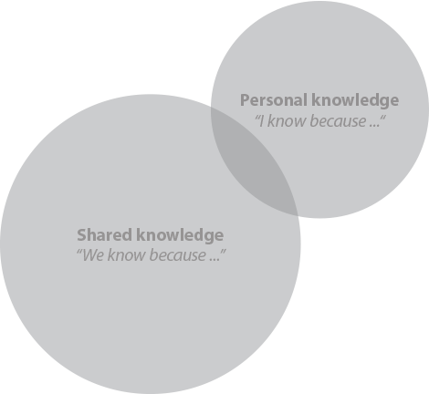
Some knowledge is knowledge that I have. For example, I might know that ‘the moon orbits the earth’. If I know this, then this is my personal knowledge. Note, however, that this piece of knowledge is knowledge that other people have as well. Thus it is also shared knowledge. Some knowledge then is both personal knowledge and shared knowledge. Note the term ‘shared knowledge’ does not imply that the knowledge is universal. Rather it merely implies that the knowledge is held by more than one person, normally in a group situation such as a family, a workplace or a community.
Other pieces of knowledge are not shared knowledge. I might know things about myself, for example, that is not known by anyone else. In this case the knowledge is personal but not shared. I might also be the first person to discover a fact about the world. Until I tell someone else, or someone else discovers the knowledge, then it is personal but not shared knowledge.
The above diagram is the way the distinction between shared and personal knowledge is normally shown. Here the knowledge is shown from the perspective of a particular person. She has some knowledge that is purely personal and also knows some but not all of the shared knowledge. If, however, we are thinking about the set of all knowledge, then the above diagram misrepresents the situation. Instead, shared knowledge is a subset of personal knowledge. This is because all knowledge, in order to be knowledge, has to be located in at least one individual. So all knowledge is personal knowledge. Some pieces of knowledge are known by more than one person, and these are described as shared knowledge. Hence, we can also display the distinction between personal and shared knowledge as follows:

Knowledge Claims and Knowledge Questions
Knowledge Claims
In TOK there are two types of knowledge claims.
- Claims that are made within particular areas of knowledge or by individual knowers about the world. It is the job of TOK to examine the basis for these first-order claims.
- Claims that are made about knowledge. These are the second-order claims made in TOK that are justified using the tools of TOK which usually involve an examination of the nature of knowledge.
Here are some examples:
- “There are an infinite number of prime numbers.” This is a first-order knowledge claim because it resides firmly inside the area of knowledge mathematics. It is established using the method of mathematical proof.
- “Mathematical knowledge is certain.” This is a second-order knowledge claim because it is about mathematical knowledge. We establish this by examining the methods of mathematics themselves using the tools of TOK.
Both types of knowledge claims might be found in TOK. The first type will feature in examples offered in the essay and presentation illustrating the manner in which areas of knowledge go about the business of producing knowledge. The second type will constitute the core of any piece of TOK analysis. There are two ways in which second-order knowledge claims are considered in TOK. First, such knowledge claims arise as a result of considering and attempting to answer knowledge questions. Second, they might form the basis of counter-claims.

Knowledge Questions
Knowledge questions are central to TOK. They will form the basis of your presentation and will occupy a central role in your essay. One of the most challenging aspects of TOK is coming to grips with the difference between knowledge questions and other types of questions.
Knowledge questions have the following characteristics:
- They are about knowledge
- They are general
- They are open
The first of these characteristics seems fairly straightforward. Failing to make their questions about knowledge, however, is also one of the common ways in which students err. The subject of a knowledge question has to be knowledge, for example the way knowledge is produced. The second characteristic, generality, indicates to us that a knowledge question should not be about a very specific example, e.g. the voting patterns of Australians in the 2016 Federal election. Rather, it should, as noted above, be a second order question that investigates knowledge in some way. Finally, the idea behind the third characteristic, openness, is that we should not be able to give a simple yes or no answer to the question. This is not to say that there is no correct answer to a knowledge question, or that all answers to a knowledge question are equal. Rather it is to say that knowledge questions allow students significant latitude in how they answer the question.
Some examples of knowledge questions:
- In what ways are our emotions important in the acquisition of knowledge?
- How should we weigh up the benefit to ourselves versus the benefits to others when deciding what to do?
- In what ways do our prior beliefs influence the way in which we perceive the world?
- Is it possible to observe the world objectively?
- Is universal agreement about what is true possible?

Ways of Knowing
The TOK course identifies eight specific ways of knowing (WOKs). They are:
- language
- sense perception
- emotion
- reason
- imagination
- faith
- intuition
- memory.
There are two central purposes to the WOKs in TOK. On the one hand they are the tools that answer the question “how do we know?” and on the other hand they help us answer the question “how do I know?” For example, we can analyse the role of imagination in the construction of shared knowledge in terms of scientific discovery, but we can also discuss imagination in the context of personal knowledge and understanding.
Below is a brief introduction to each WOK. The questions preceding the description of each WOK are simply stimulus questions, designed to promote discussion and raise awareness of the individual WOKs and their impact on knowledge.

Language
Language can refer to the mental faculty which allows people to learn and use complex communication systems, or it can refer to those systems themselves. Language consists of a system of signs with agreed or conventional meanings combined according to a set of rules for the purposes of communication, formulation of ideas, storage of knowledge or as a medium of thought. The term “signs” can be interpreted very broadly to include letters, symbols, sounds, gestures, images and even objects. Language is a crucial part of our daily lives, but is also filled with potential problem areas, for example, ambiguity, sarcasm, irony and translation issues.
Language plays an important role in communicating knowledge. However, some see language as having an even more central role, arguing that language doesn’t just describe our experiences of the world but in fact actually structures those experiences. In the section on the knowledge framework there is a discussion about whether certain types of knowledge are actually constituted by language—the idea that language is part and parcel of the knowledge claim itself and not merely a description of something that exists independently of language. The view that facts about the world might be determined by the language is called linguistic determinism.

Sense perception
Sense perception is the process by which we can gain knowledge about the outside world. Traditionally, there were believed to be five senses: sight, touch, smell, taste and hearing. However, many now argue that there are others such as a sense of heat, sense of pain, sense of movement, sense of balance and the senses of hunger and thirst, or a sense of where our body parts are.
Historically, the view that the senses provide the basis for all our knowledge was challenged by the idea that prior concepts might be needed before any perception takes place at all. Indeed, it is common now to view sense perception as an active process of interpreting the world according to prior expectations, conceptual frameworks and theories. There is, therefore, some disagreement as to whether we directly perceive the world as it is, or whether perception is an active process where we supply much of the content of our experiences ourselves.

Emotion
The naturalistic view of emotions is that they are the products of natural processes, with physiological causes and effects. One supporter of this view was Darwin, who believed that emotions are purely physiological and therefore universal and experienced across all cultures. However, there seem to be many examples of culturally bound emotions, for example, the Chinese notion of “sad love”. The opposite view is therefore that of the social constructionists, who argue that emotions depend on a social consciousness, and have no natural basis at all. For example, emotions such as shame seem to presuppose a notion of right and wrong.
Emotion has sometimes been regarded as an unreliable way of knowing. Emotions have, for example, been criticized as being irrational obstacles to knowledge that distort our picture of reality. However, others believe that not only do emotions help make sense of social and cultural experiences and behaviours, but they are also the source of social, ethical and political knowledge by helping us form an understanding of the world around us.

Reason
Reason allows us to go beyond the immediate experience of our senses. It is closely linked to logic - the deducing of valid conclusions from given starting points or premises. Human reasoning can also be inferential in nature, allowing conclusions to be drawn that cannot be strictly deduced from their premises. It then becomes an interesting question of whether standards of rationality and norms of reasoning are grounded in culture. Areas of knowledge might set their own requirements for the types of reasoning that are accepted.
Inductive reasoning is the process of supporting general statements by a series of particular ones - the reverse of deductive reasoning which tends to proceed from the general to the particular. Inductive reasoning is by its nature inferential. Statements involving the word “all” are often not strictly provable given the difficulties in making observations of an infinite set of particulars. This is of importance in the natural sciences but also in human sciences such as psychology and economics.

Imagination
Imagination is often identified in a narrow sense as the capacity to form a mental representation of something without the stimulus of sense experience. Traditionally imagination has been associated with imagery and making a mental image of something. However, more recently interest in the imagination has also focused on exploring propositional imagining, or “imagining that”. The importance and power of the imagination is highlighted by a number of medical conditions which impact upon it, for example, conditions which can impair imagination such as severe autism, or conditions which can cause delusions such as severe schizophrenia.
Imagination is sometimes viewed in a broader way as being associated with creativity, problem-solving and originality. Here it might be the making of connections between otherwise disparate ideas in order to solve problems. This might be useful in model making or theory creation in the sciences and solving structural problems in the arts. Imagination is, however, also sometimes distrusted, in part because it is regarded as something that is derived in the mind of the individual and therefore subjective. Imagining is also sometimes associated with counterfactual reasoning; imagining “what would happen if …”, or “what would have happened if …”.
Imagination is also sometimes associated with possibility, in that it can be argued that only things which are possible can be imagined. In this way, the imagination is seen by some to provide evidence of what is and is not possible. In daily life, imagination has a particularly prominent role in entertainment, for example, fictional films or television programs. However, it can be argued that imagination also plays a deeper role, for example, in moral education, developing empathy, or providing opportunity for self-expression and an increased understanding of the self.

Faith
The term “faith” is most frequently used to refer specifically to religious faith, but can also be used in a secular sense as a synonym for trust. Although most associated with belief in a God or gods, faith can be religious without being theistic, for example, in Buddhism. Alternatively it can be seen as a commitment to a particular interpretation of experience and reality which is not necessarily religious at all, such as humanism. Logical positivism claims that statements of faith have no meaningful cognitive content, so it doesn’t make sense to speak of faith as a way of knowing. However, for many people faith is a key way in which they try to understand and explain the world.
The evidence on which faith is based on is often controversial. This is particularly the case in the example of scripture, which those within the religious group often see as infallible evidence, while those outside the religious group might be more circumspect. While critics argue that faith is irrational and incoherent, others would argue that faith should be seen as a way of going beyond reason rather than being purely irrational. Indeed, although faith is often contrasted with reason, many religions regard faith and reason as interdependent, for example, natural theology argues that it is only possible to access God through reason, and many religions regard reason as a God-given gift.
Some would argue that the criticism and controversy surrounding the evidence for faith claims is misplaced, arguing that faith is an act of trust and is an example of knowledge which is not evidence based. Indeed, in some traditions belief that is not based on evidence is seen as superior to belief that is based on evidence, the demand for concrete evidence being seen to signify a lack of faith.

Intuition
Intuition is sometimes described as immediate cognition, or knowledge which is immediately evident without prior inference, evidence or justification. Intuition is often contrasted with reason, as it is regarded as knowing without the use of rational processes. Jung (Psychologische Typen 1921) famously referred to intuition as perception via the unconscious, highlighting the idea that intuition is often seen as beliefs which are known without understanding how they are known.
Intuition is sometimes associated with the concepts of instinct and innate knowledge. For example, some would argue that although we do not have innate knowledge of any particular language, we have an intuitive capacity to use language. Intuition has been much discussed in the field of ethics in terms of whether we have moral intuition, or a kind of innate sense of right and wrong. It is also seen by some to play an important role in scientific advances.
To know something by intuition is to know something through introspection or an immediate awareness. In this way, some argue that it is impossible to justify, or that as it is immediately evident it requires no further justification. Some people are regarded as more intuitive than others, with intuitive people often being said to make quick instinctive decisions without having any identifiable rationale for those decisions. However, some have denied the existence of intuition as a separate way of knowing. For example, it has been suggested that intuition is a term which is often used to describe a combination of other ways of knowing, such as prior experience, heightened sense perception and an active imagination.

Memory
Many discussions of knowledge tend to focus on how beliefs and knowledge are formed rather than on how they are remembered by the individual. However, most of the knowledge that individuals have is in the form of memory and therefore how we retain information and how past events and experiences are reconstructed is an important aspect of how personal knowledge is formed.
Memory, and particularly habit, has a strong link to procedural knowledge and remembering how to perform actions. In contrast to perception, memory refers to things which are not currently happening. And in contrast to imagination, memory refers to things which we believe really happened. Some would argue that memory is not itself a source of knowledge, but instead is a process which we use to recall knowledge gained in the past. However, although memory refers to knowledge gained in the past, it can be argued that even new knowledge is dependent on and influenced by memory. For example, how we interpret new situations can be heavily influenced by experience and previous events. In this way, apart from being a “storage unit” for existing knowledge, memory can also be a mechanism that allows us to process new and unique situations.
The importance of memory can be highlighted by imagining the challenges that would be presented by losing our memory. Because so much of our personal knowledge is in the form of memory, issues surrounding the reliability of memory are also crucial. Memory retrieval is often regarded as unreliable, for example, because it is seen to be subjective or heavily influenced by emotion. However, we rely on our memory every day and because many of our memories seem to be reliable, this gives us confidence that our other memories are reliable.

Areas of Knowledge
How do we know things? We know things because we use a range of methods of inquiry that incorporate ways of knowing to help construct knowledge in different areas of knowledge (AOKs).
The theory of knowledge course distinguishes between eight AOKs:
- mathematics
- natural sciences
- human sciences
- history
- the arts
- ethics
- religious knowledge systems
- indigenous knowledge systems.
Below is a brief introduction to each AOK:

Mathematics
Mathematics is founded on a set of more or less universally accepted definitions and basic assumptions. It proceeds from a system of axioms using deductive reasoning to prove theorems or mathematical truths. These have a degree of certainty unmatched by any other area of knowledge, making it excellent raw material for study in TOK.
Despite, or rather because of, the strict confines of mathematical logic, mathematics is an enormously creative subject, asking of its practitioners great leaps of the imagination. Pure mathematics requires no prior sense perception at the start of inquiry but the application of mathematics to real-world situations requires techniques such as those used in the natural and human sciences. Indeed, most research in the natural and human sciences is underpinned by mathematics. There are also often close links between mathematics and the arts where formal requirements for harmony or symmetry impose mathematical structures on a work.

Natural sciences
The natural sciences seek to discover laws of nature—regularities in the natural world. These are often causal relationships of the form “if X happens then Y will be the result”. This description implies that there is an attempt to produce a system of knowledge that is independent of human agency. Whether this is indeed possible is a matter of debate.
The methods of the natural sciences based on observation of the world as a means of testing hypotheses about it are designed to reduce the effects of human desires, expectations and preferences, in other words they are considered objective. In this sense, the natural sciences emphasize the role of empirical inquiry: scientific knowledge must be able to withstand the test of experience and experiment.
One interesting area of discussion is what differentiates the scientific from the non-scientific. Many would suggest that it is the methods used in science. It is therefore interesting to consider what it is about these methods that mean that the knowledge they generate is often regarded as more reliable than those employed by other AOKs.

Human sciences
In TOK , the term “human sciences” includes many of the subjects in group 3 (individuals and societies) in the Diploma Programme. In simple terms, the human sciences study the reality of being human. More specifically, the human sciences study the social, cultural and biological aspects of human existence. If we add the study of human behaviour to this definition then the Diploma Programme offerings cover a range of human sciences including psychology, social and cultural anthropology, economics and geography.
A fundamental difference between human sciences and natural sciences is in the interpretation of the word “science”. The human sciences might be classified as science because they use the scientific method to test the validity and reliability of hypotheses. However, unlike the natural sciences, the phenomena they try to explain might not possess hard and fast laws that admit no exceptions. They might therefore resort to statistical methods to establish their findings, producing knowledge that is less reliable in terms of issuing predictions.

History
History is an area of knowledge that studies the recorded past. It raises knowledge questions such as whether it is possible to talk meaningfully about a historical fact and what such a fact might be, or how far we can speak with certainty about anything in the past. Studying history also deepens our understanding of human behaviour, as reflecting on the past can help us to make sense of the present.
Documentary evidence plays an important role in history, which raises questions about the basis for judgments of reliability of that evidence. The individual historian also plays an important role in history and in the 20th century there was much debate over whether historical facts exist independently of historians. Some argue that there is always a subjective element in historical writing because historians are influenced by the historical and social environment in which they are writing and this unavoidably affects their selection and interpretation of evidence.

The arts
“The arts” is a collective term that encompasses the creative productions of humans and encompasses the visual arts, the performing arts and the literary arts. The arts explore the experience and reality of being human and are an essential element of culture.
The arts could be thought of as creating a bridge between personal knowledge and shared knowledge. Many of them are collaborative. They use emotion as a currency to generate significance at a personal level but reason provides a restrictive framework necessary for the creation of meaning: artworks have their own inner logic. Some regard the arts as having an extra-artistic cognitive function, that they have a message about man’s place in the world which might have social or political implications. For example, there might be a case for supposing that the arts have an important function as a medium for social criticism and transformation. In any case, there is a widespread belief that the arts have a higher purpose to educate by encouraging introspection and sometimes making us think about how we should live our lives.

Ethics
One thing often said to distinguish humans from other animals is morality. A key question in ethical discussions in TOK is therefore whether we can really know whether something is moral. What is peculiar about moral values is that they seem to embody obligations for action.
An example of a key area of discussion in ethics is the issue of moral rules. There is disagreement about whether being moral is about following rules, not least because some would question whether moral rules really exist at all. There is also debate about whether moral rules should ever be broken, and if so, in what circumstances. Other key areas of discussion include the issue of whether humans are essentially altruistic or selfish, or whether the consequences of, or motivation for, an action is the location of moral value.

Religious knowledge systems
Religious knowledge systems offer answers to fundamental questions about the meaning and purpose of human life. This area of knowledge incorporates a diverse range of different beliefs and systems; for example, varieties of theism, pantheism and polytheism. Some people believe that there is one true religion whereas others, known as religious pluralists, argue that the different religions are just different reflections of the same underlying truth. Religious knowledge has both a shared and personal dimension and offers a concrete context, within the TOK classroom, to explore the links between the two.
Religion is often regarded as a sensitive area in which discussions should be had with caution, in part because people have very personal and deeply held convictions regarding religious matters. However, for many people their religion has a major impact on how they understand the world, permeating their thinking and influencing their understanding of other AOKs, for example, the idea that ethics and religion are inextricably linked. In any case, for many, religion provides a backdrop to all the other knowledge they have.

Indigenous knowledge systems
Indigenous knowledge systems explore local knowledge unique to a particular culture or society. The term usually refers to the knowledge constructed by a particular group of people such as the Namaqua people of Southern Africa, the Secoya people of Ecuador and Peru, the Ryukyuan people of Japan and the Wopkaimin people of Papua New Guinea. An important feature of indigenous knowledge systems is that they are not static. They are dynamic as a result of both internal and external influences. The Maori knowledge system today, for example, is a mixture of traditional knowledge and knowledge inherited over time from exposure to European culture.
TOK students can explore this AOK from a general, broad point of view to raise awareness of the diversity of indigenous knowledge systems or they could study a particular indigenous knowledge system. When studying indigenous knowledge systems, it is important to examine the methods of communication, decision-making processes, thinking processes and the holistic view of knowledge.

Assessment Summary and Important Dates
There are only two assessment tasks in TOK, namely an essay and a presentation. The essay counts for two-thirds of a student’s final grade while the presentation counts for one-third. Essays are marked out of 10, but this mark is then doubled and added to the score for the presentation, giving each student a final score out of 30.

Essay
Each March, the IB releases a set of 6 essay titles. Students must write an essay of a maximum of 1600 words based on one of these titles. The essay titles are designed to test the student’s ability to form knowledge questions, to think about these knowledge questions carefully and analytically, to consider alternative perspective, and to form conclusions on the basis of the foregoing.

Presentation
Each student must do a presentation, either individually or in a group of no more than three, based on a real-life situation. This situation must be analysed and a related knowledge question formed. The majority of the presentation is then centred around a discussion of this knowledge question, not the real-life situation.
Presentations are approximately 10 minutes in length per person, up to a maximum of approximately 30 minutes long for a group of three. Presentations receive a mark out of 10.

Important Dates
Term 4, 2019: First presentation
Term 1, 2020: Second presentation
March, 2020: Essay topics released
September 2020: Final essays due

Essay Guide
Background
When thinking about how to write your essay, it is useful to have an understanding of how it will be marked. In general, assessors will read through the essay once and make a provisional judgment about the level (1-5) in which the essay fits. They will then read the essay a second time and decide whether the essay is worthy of the higher mark within the band. Finally, brief comments are usually made and a final mark is given.
When marking an essay, however, assessors do not just refer to the marking criteria. In addition, assessors are given general instructions by the Chief Assessor along with specific instructions for each question. These guide the ways in which the assessors approach the essays that they examine and to a large extent dictate how the essays will be marked. Assessors are expected to internalise the Chief Assessor’s approach to each question and grade on that basis rather than each assessor having their own individual approach. This is designed to ensure consistency across assessors. It does, however, mean that certain types of approaches to writing the essay are likely to be penalised quite severely. The remainder of the guide below is designed to help you avoid these approaches.

Structure
When writing your essay, it is very important to ensure that it has a clear structure. This means that by the end of the first paragraph, the assessor who reads your paper should have a very clear idea of what to expect in the remainder of the essay. You cannot receive the highest marks without this. Each assessor is asked to mark a minimum of 210 essays. For most people, this is more than 50 hours of work. Assessors are fallible and if they cannot see early on what your essay is about and the basic points you are going to make then, even if the essay makes some interesting and pertinent points, you are likely to get marked down. So, make sure that your essay is clear!
The first page of your essay should include the following:
- A clear introduction
- Unpacking of the title
- Provide a thesis that gives the paper a clear direction and which addresses the title
- Identifies a clear and relevant knowledge question (see below)
Once you have set up the essay by telling the assessor what is to come, your essay should not deviate from this structure. Make sure that it is clear to the reader why you are discussing the particular points in question.

Knowledge Questions
One of the easiest ways to obtain a low mark for the essay is to either fail to state a knowledge question or to discuss a knowledge question that is not tightly connected to the topic. The simplest way to generate your primary knowledge question is to reformulate the topic into a question. For example, one of the topics for the May 2016 Session was:
“The knower’s perspective is essential in the pursuit of knowledge.” To what extent do you agree?
A straightforward knowledge question here would be “Is the knower’s perspective essential in the pursuit of knowledge?” A knowledge question like this ensures that the focus of your essay remains on the topic and that you include in your knowledge question all of the important terms. Note that if your knowledge question was something like “Is the knower’s perspective important in the pursuit of knowledge” then you run the risk of being marked down. This is because you are not likely to have considered the term ‘essential’ in your essay and this was deemed by the Chief Assessor to be important. An essay that failed to discuss this term would likely only receive a score in level 2.
Note that although there is no requirement for your knowledge question to be explicit (they can be embedded in the flow of the essay), failing to be explicit places you at risk as a tired or inattentive assessor might overlook it. Your best option then is to say something along the lines of “The main knowledge question that I will examine in this essay will be …”. (Using the first person is absolutely fine in TOK – this is not an English essay).
As your essay develops, you may also (but are not required to) have some subsidiary knowledge questions. It is less essential that these are explicit, although I would still recommend making them obvious. Always ensure that the subsidiary knowledge questions are directly related to the topic and help you answer your primary knowledge question. In the context of the topic above, some good subsidiary knowledge questions might be:
- In what circumstances might the knower’s perspective hinder the pursuit of knowledge?
- Is the knower’s perspective more relevant in some areas of knowledge than others?
- What are the components of a knower’s perspective? Are they all essential in the pursuit of knowledge?
Subsidiary knowledge questions that are irrelevant to the topic are likely to result in a lower grade for your essay.

Examples
Your discussion needs to be supported through the use of effective and original examples. The use of common examples suggests a lack of engagement. Such essays tend not to reach further than level 3. Incidentally, this is one of the primary reasons to avoid using websites like theoryofknowledge.net for inspiration as the examples on sites like this tend to be used very frequently. Hence, using these examples actually disadvantages you. Note that the examples that you use do not have to be personal anecdotes, and indeed personal examples do not always work well in the context of the essay. If you have a personal anecdote that is directly relevant then you can use it, but in general anecdotes are best avoided. What the assessors are looking for is personal engagement with the topic rather than personal anecdotes.

Claims and Counterclaims
Whenever you make a claim within the body of the essay, make sure that you also provide a counterclaim. This does not mean that you have to reject your original claim, but it does mean that you need to consider whether your claims are true and how someone might object to them. Exploration of these counterclaims, e.g. through showing why they are mistaken, is essential in order to get marks in either bands 4 or 5.

Conclusion
The conclusion should remind the reader of the general outline of the essay (claims and counterclaims) and state your position with respect to the topic. Nuanced responses are to be encouraged, e.g. “The knower’s perspective is essential in ways X and Y, but not in way Z”. Do not just present the opposing views and then try to remain neutral – the essay should develop and support your view. Finally, either in the conclusion or just prior to the conclusion, you should consider the implication of the view for which you have just argued. Without this you cannot receive the highest score.

Further Thoughts
- Avoid long descriptive passages of text that do not directly relate to your answering the main knowledge question.
- Do not use information/plans from TOK help sites
- Do not exceed 1600 words (results in an automatic 1 mark deduction)
- Avoid going under 1300 words (this is a good indicator of a low mark)

Assessment
Essays receive a score out of 10, which is then doubled to provide a score out of 20. Essays are marked using the assessment instrument below:
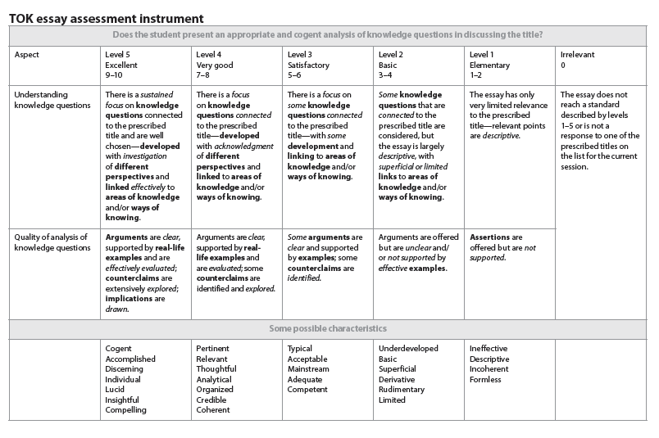

Presentation Guide
The first of the assessed tasks is the presentation. This is worth a third of your final grade for TOK. The presentation may be done individually or in groups of up to 3 students. The maximum length of the presentation is approximately 10 minutes per student; a group of three students then will have up to 30 minutes for their presentation.
The TOK presentation requires students to identify and explore a knowledge question raised by a substantive real-life situation that is of interest to them. The selected real-life situation may arise from a local domain of personal, school, or community relevance, or from a wider one of national, international or global scope.
The structure of the presentation should follow the outline below:

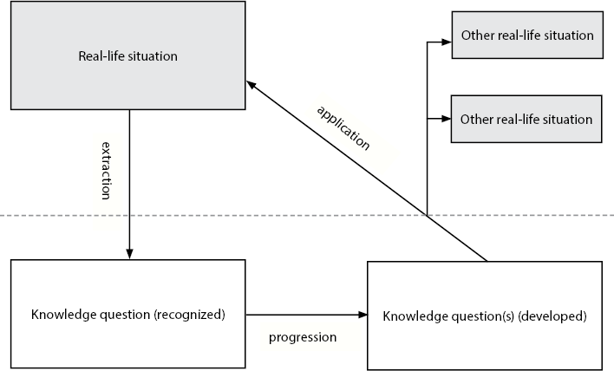
As the diagram suggests, student presentations should have the following structure:
- Students first begin with a real-life situation (RLS). This RLS should be described in enough detail that listeners are able to understand the situation and how it might be relevant to TOK.
- From the RLS, students extract one knowledge question. The bulk of the presentation should then focus on this knowledge question, not on the real-life situation.
- This knowledge question is then analysed in depth and students develop their approach to the question. At least two perspectives should be considered in this discussion and these perspectives should be on the KQ and not on the RLS. Students should develop an answer to the KQ and provide arguments and examples to support this answer.
- The students’ findings are then applied to the original real-life situation and to at least one other real-life situation. The aim here is to demonstrate that the conclusions arrived at through the exploration of the KQ are generalisable to other RLSs. Students who are doing a presentation by themselves will probably only have time to do this for one other RLS. Students in groups may want to look at two other RLSs.
Exploring the Knowledge Question
The majority of the presentation will be focused on the exploration of the KQ. There are many forms that this exploration might take. For instance, one might split the KQ into components, then analyse each component and finally put the component parts together in order to answer the KQ.
Students must provide and evaluate arguments from at least two perspectives. If, for example, you are doing a talk on the ethics of giving to charity, you might consider the perspectives of utilitarianism and virtue ethics. A good talk would outline these perspectives, provide arguments regarding them and then come to a conclusion as to which is the more plausible in the context of the KQ. These arguments should be supported by examples, either from the student’s life or ones that have arisen out of the research on the topic.
Students should be careful that their exploration focuses on the KQ that they have identified as being central to their talk and not on either the RLS or on tangential KQs. Failing to focus on the central KQ will result in a poor mark. Students must, at the end of their exploration, come to a reasoned conclusion about the KQ. This does not have to be a simplistic conclusion; nuanced conclusions often indicate a more sophisticated analysis.

Assessment of the Presentation
The presentation is assessed via two related instruments. First there is the global impression instrument which underpins the assessment instrument below. The global impression instrument looks as follows:

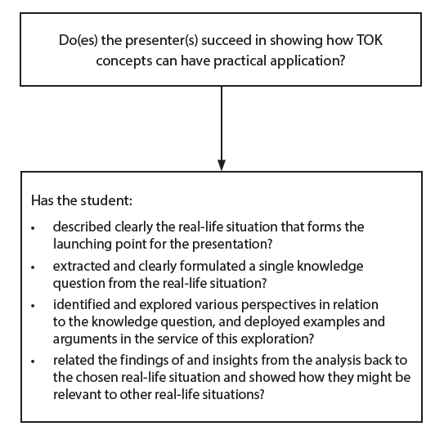

These four dot points correspond to the suggested structure above. The second instrument is the presentation assessment instrument. This is presented below:

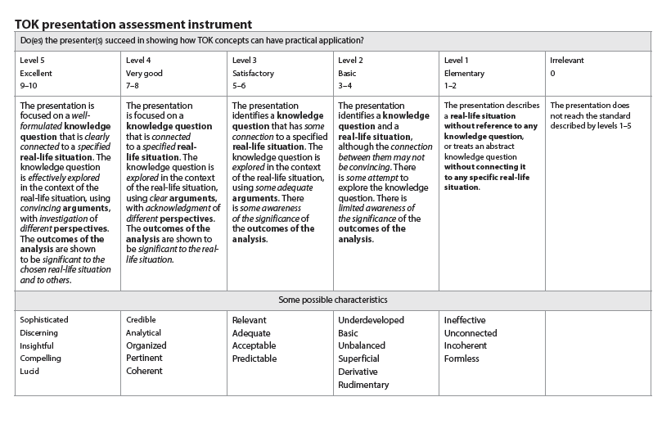
As is clear from this instrument, students will receive a score out of 10 for their presentation. The points above are not a simple checklist. Teachers are directed to use global impression marking, which entails teachers looking to see which level best fits the presentation that they have viewed. From the perspective of the student, however, the above instrument does provide a clear indication of what is expected. Notice that three sentences describing level 5 essentially correspond to the global impression instrument and the suggested structure outlined above.
Most of the differences between grades will be due to the quality of the exploration and the arguments. In order to be in level 5, these must be effective and convincing respectively, whereas for level 3 KQs must be merely explored and arguments must be adequate.

Further Points
- There is no need to have more than one KQ. Both the global impression instrument and the assessment instrument describe one KQ. Having more than one KQ may result in a talk that fails to concentrate on the primary KQ. The exception to this is where students have subsidiary KQs that help them to answer the primary KQ. This is acceptable and may be helpful, but care must be taken to ensure that these subsidiary KQs are appropriate.
- The majority of the presentation should focus on the exploration of the KQ. Students should explore different perspectives on the KQ and present arguments and examples. They should then come to a conclusion about the KQ. This does not have to be definitive, but may represent the student’s best judgment.
- Presentations should be approximately 10 minutes per student. Groups will be cut off one minute after this time.

TK/PPD Form
At the time of their presentation, students are required to submit a completed TK/PPD form. While the TK/PPD form does not contribute to the mark awarded by the teachers, it is an important, indeed the only, factor that is used in the moderation of the cohort’s marks. As such, students should ensure that the form which they hand in accurately reflects both the content and the organization of the presentations. Failure to do so may result in the mark being moderated down. Conversely, an excellent TK/PPD form may result in the marks awarded being moderated upwards.

Notes

